Grid-Based Dissection

Definition
# Source: AI Source: Provided by: [Data Path: Persons Table -> ID Column: 1, Name_En Column: Motasem Essam] -> From: [ChatGPT] on [7/25/2026]
Grid-Based Dissection is a geometric dissection method in which a figure is divided into smaller pieces using a grid of intersecting horizontal and vertical lines. The resulting pieces are often squares, rectangles, or smaller grid-aligned regions that can be counted, measured, rearranged, or combined to form another figure.
Grid-based dissection is useful for studying area, equal partitions, geometric patterns, and transformations that preserve area.

Simple Definition
# Source: AI Source: Provided by: [Data Path: Persons Table -> ID Column: 1, Name_En Column: Motasem Essam] -> From: [ChatGPT] on [7/25/2026]
Grid-based dissection means dividing a geometric figure into smaller pieces using a grid, then using those pieces to analyze or reconstruct the figure.
For example, a square divided into a \(3\times3\) grid contains nine equal smaller squares.
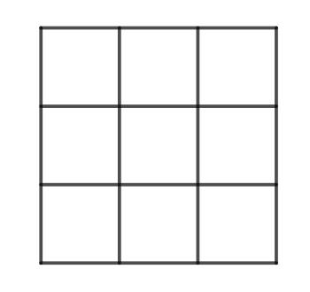
mathx.vn

Main Classification
# Source: AI Source: Provided by: [Data Path: Persons Table -> ID Column: 1, Name_En Column: Motasem Essam] -> From: [ChatGPT] on [7/25/2026]
The following is a practical classification of grid-based dissection methods. These categories are descriptive rather than a universally standardized mathematical taxonomy, and some can overlap.

1. Equal-Cell Grid Dissection
# Source: AI Source: Provided by: [Data Path: Persons Table -> ID Column: 1, Name_En Column: Motasem Essam] -> From: [ChatGPT] on [7/25/2026]
Divides a figure into grid cells of equal dimensions.
Example: A square of side $8$ divided into $4×4$ equal squares, each with side $2$.
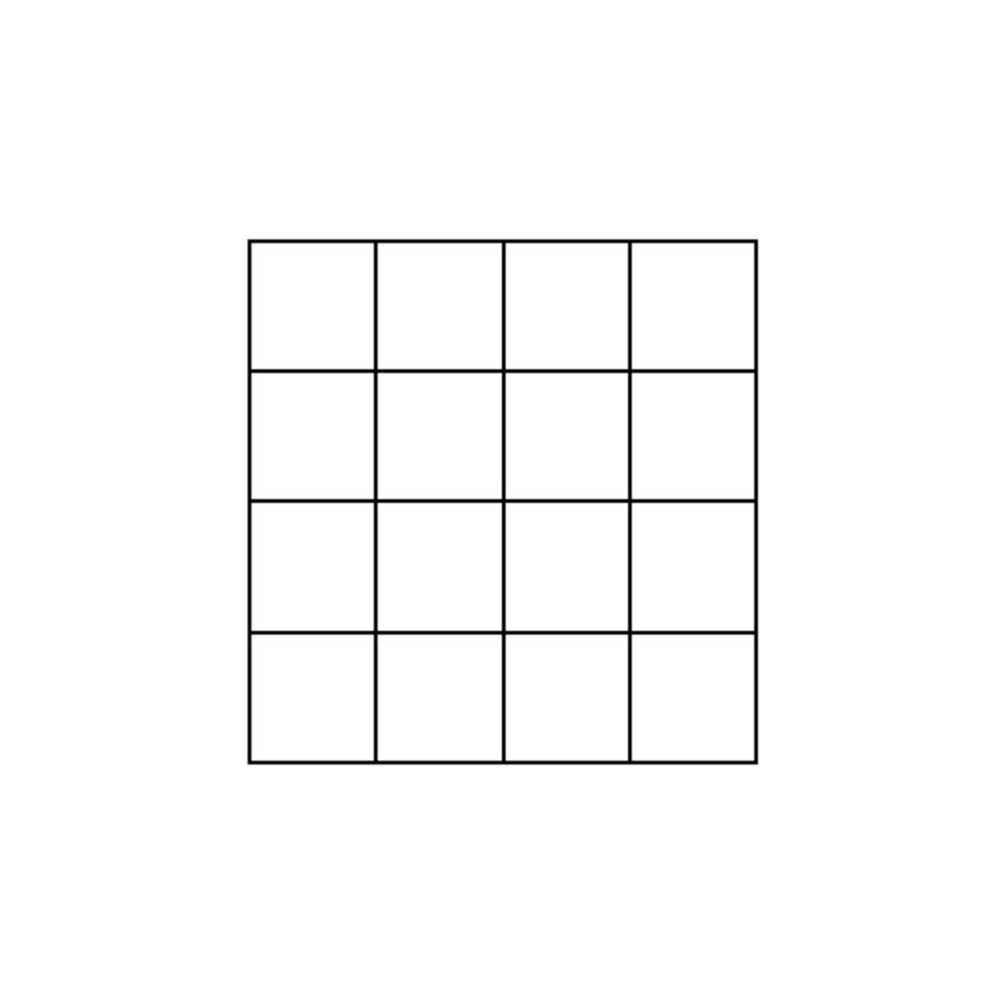
Detailed Explanation of Each Type
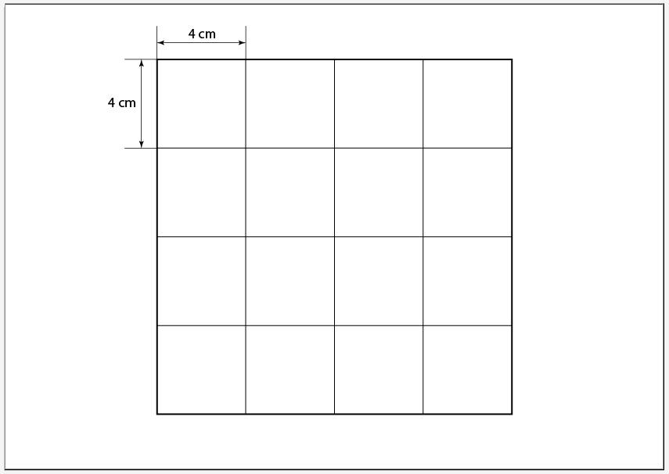
Definition: A dissection in which all grid cells have the same shape and dimensions.
Example: A square has side length $8$. Divide each side into four equal segments.
- Number of columns: $4$
- Number of rows: $4$
- Total cells: $4×4=16$
- Side length of each cell: $8/4=2$
- Area of each cell: $2×2=4$
The original area is
$$A=8^{2}=64$$
The sum of the cell areas is
$$16×4=64$$
Therefore, the grid preserves the original area.

2. Unequal-Cell Grid Dissection
# Source: AI Source: Provided by: [Data Path: Persons Table -> ID Column: 1, Name_En Column: Motasem Essam] -> From: [ChatGPT] on [7/25/2026]
Uses grid lines that create cells with different dimensions.
Example: A rectangle divided into columns of widths $2$, $3$, and $5$.
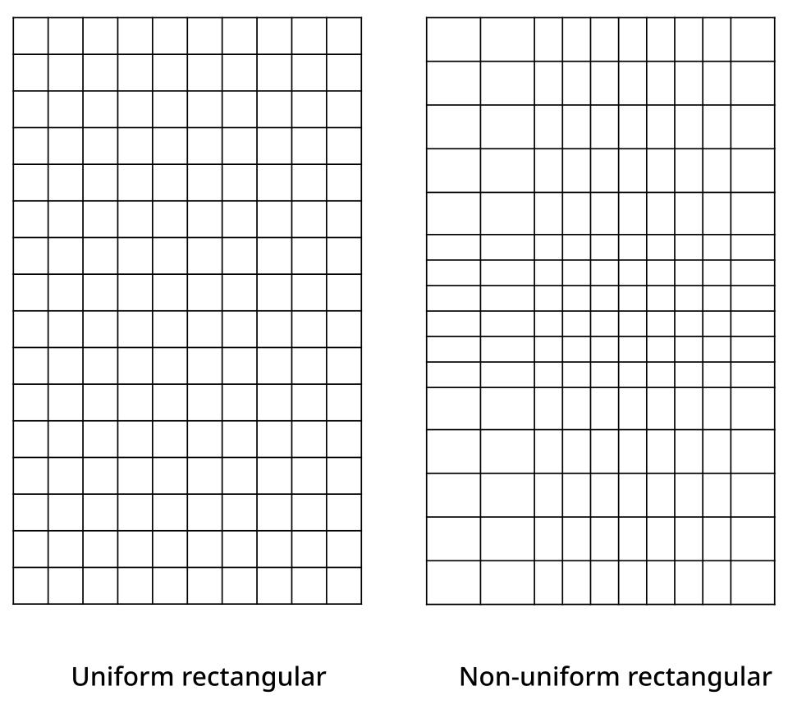
Detailed Explanation of Each Type
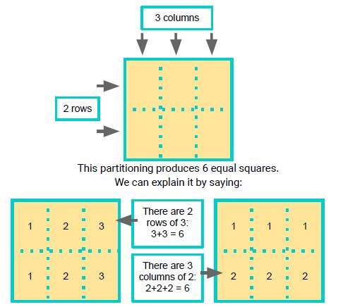
Definition: A grid-based dissection in which cells have different dimensions because the spacing between grid lines varies.
Example: Consider a rectangle with width $10$ and height $6$. Divide it into three columns of widths $2$, $3$, and $5$, and two rows of heights $2$ and $4$.
The cell areas are:
- First column: $2×2=4$ and $2×4=8$
- Second column: $3×2=6$ and $3×4=12$
- Third column: $5×2=10$ and $5×4=20$
Total area:
$$A=4+8+6+12+10+20=60$$
This equals the original rectangle's area:
$$A=10×6=60$$

3. Partial-Grid Dissection
# Source: AI Source: Provided by: [Data Path: Persons Table -> ID Column: 1, Name_En Column: Motasem Essam] -> From: [ChatGPT] on [7/25/2026]
A grid divides only part of a figure, leaving some regions larger or unpartitioned.
Example: A rectangle has a \(2\times2\) grid in one portion and a single undivided rectangular region beside it.
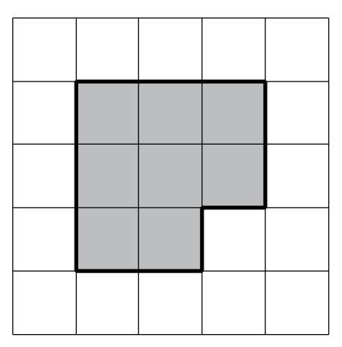
Detailed Explanation of Each Type
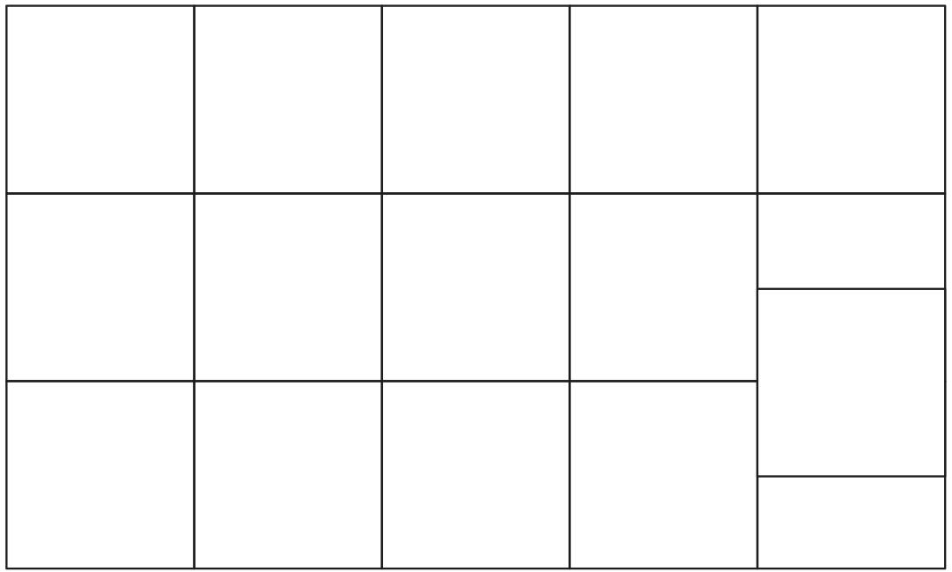
Definition: A method that applies grid lines to only part of a figure, leaving other portions as larger pieces.
Example: A $10×6$ rectangle is divided into a $2×2$ grid over its leftmost $4$ units of width. The remaining $6×6$ portion stays undivided.
- Left region: four $2×3$ rectangles, each with area $6$.
- Right region: one $6×6$ square, with area $36$.
Total area:
$$A=4\left(6\right)+36=60$$
Partial grids are useful when a complete grid would create too many unnecessary pieces.

4. Irregular-Figure Grid Dissection
# Source: AI Source: Provided by: [Data Path: Persons Table -> ID Column: 1, Name_En Column: Motasem Essam] -> From: [ChatGPT] on [7/25/2026]
Applies a grid to an irregular or rectilinear figure, producing complete and partial cells.
Example: An L-shaped region divided by horizontal and vertical grid lines.
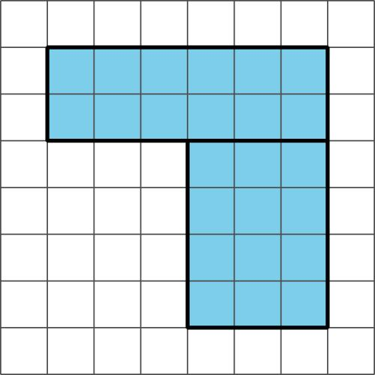
Detailed Explanation of Each Type
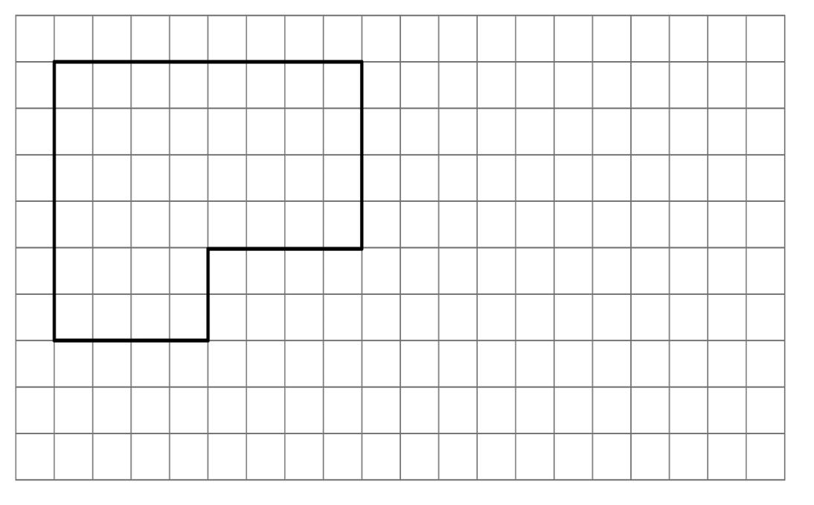
Definition: A grid-based dissection applied to a figure that does not form a complete rectangle or square.
Example: An L-shaped figure is formed from a $6×8$ rectangle by removing a $3×4$ rectangle from one corner.
The area of the original rectangle is
$$A_{1}=6×8=48$$
The removed area is
$$A_{2}=3×4=12$$
Therefore, the L-shaped area is
$$A=48-12=\boxed{36}$$
Grid cells help count the remaining complete cells and identify the boundaries of the removed region. For partial cells, calculate their areas separately.

5. Strip-Based Grid Dissection
# Source: AI Source: Provided by: [Data Path: Persons Table -> ID Column: 1, Name_En Column: Motasem Essam] -> From: [ChatGPT] on [7/25/2026]
Uses repeated parallel grid lines to form strips, which may then be subdivided further.
Example: A rectangle divided into five equal-width vertical strips.
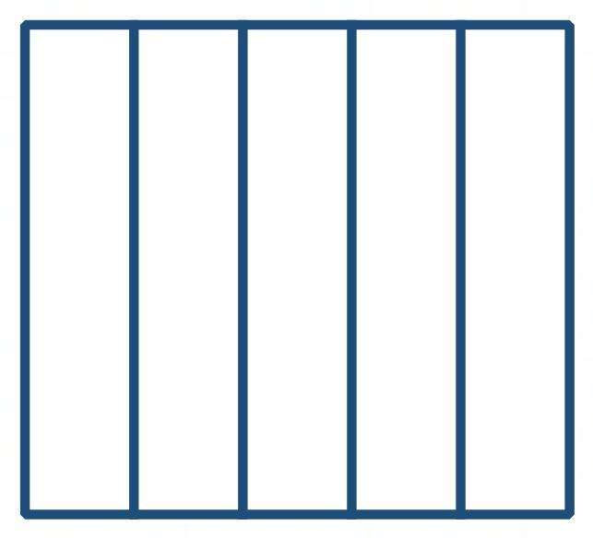
Detailed Explanation of Each Type
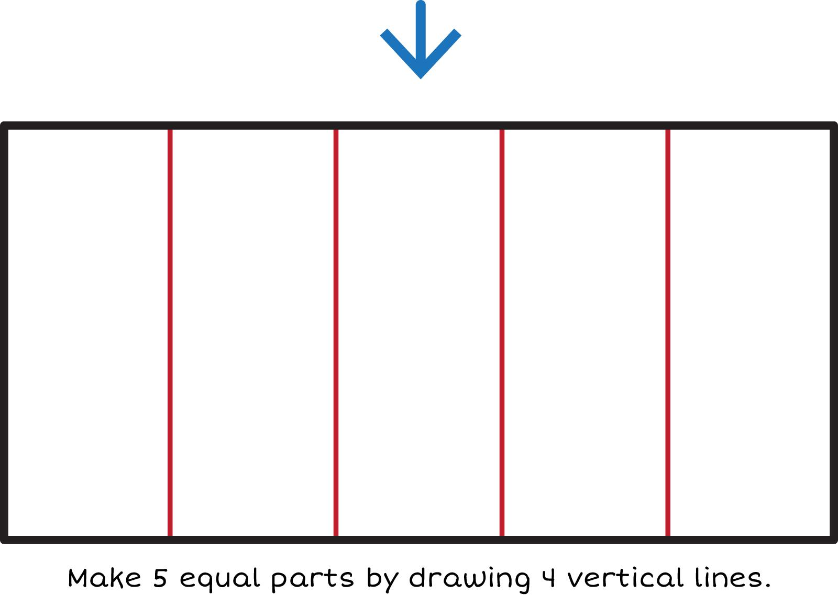
Definition: A dissection that divides a figure into strips using parallel grid lines.
Example: A rectangle of width $15$ and height $8$ is divided into five equal vertical strips.
Width of each strip:
$$w=\frac{15}{5}=3$$
Area of each strip:
$$A_{\text{strip}}=3×8=24$$
Total area:
$$A=5×24=\boxed{120}$$
Horizontal strips can be used in the same way.

6. Multi-Stage Grid Dissection
# Source: AI Source: Provided by: [Data Path: Persons Table -> ID Column: 1, Name_En Column: Motasem Essam] -> From: [ChatGPT] on [7/25/2026]
Divides a figure into grid regions and then subdivides selected regions again.
Example: Divide a square into four equal squares, then divide each smaller square into four more squares.
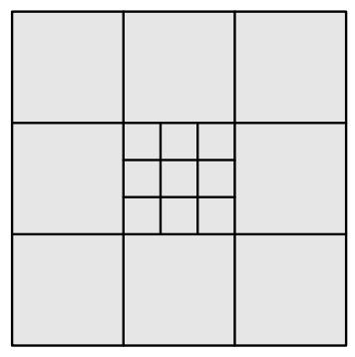
Detailed Explanation of Each Type
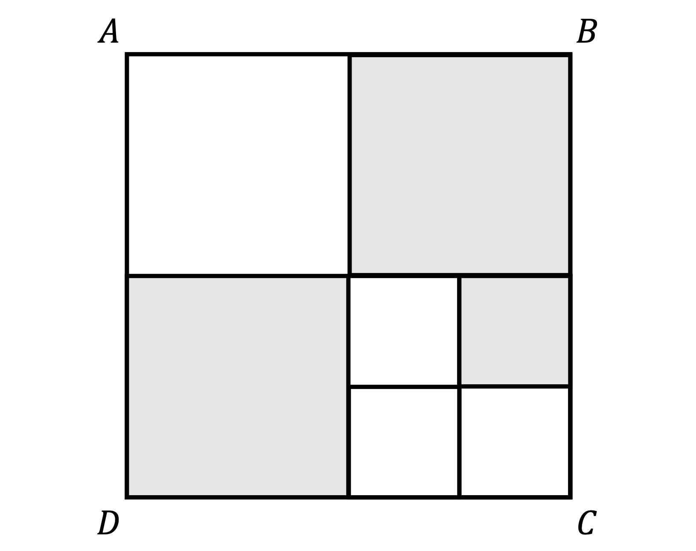
Definition: A method that divides a figure into grid cells and then subdivides selected cells into smaller pieces.
Example: A square of side $8$ is divided into four $4×4$ squares. Each of those four squares is then divided into four $2×2$ squares.
There are
$$4×4=16$$
small squares, each with area
$$A_{\text{small}}=2×2=4$$
Thus,
$$A_{\text{total}}=16×4=\boxed{64}$$
The result is the same whether the square is counted at the first stage or the final stage.

7. Pattern-Based Grid Dissection
# Source: AI Source: Provided by: [Data Path: Persons Table -> ID Column: 1, Name_En Column: Motasem Essam] -> From: [ChatGPT] on [7/25/2026]
Uses a grid to create repeated or alternating arrangements of pieces.
Example: A checkerboard pattern formed by alternating shaded and unshaded square cells.
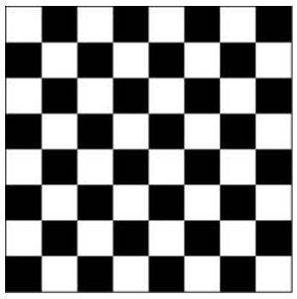
Detailed Explanation of Each Type
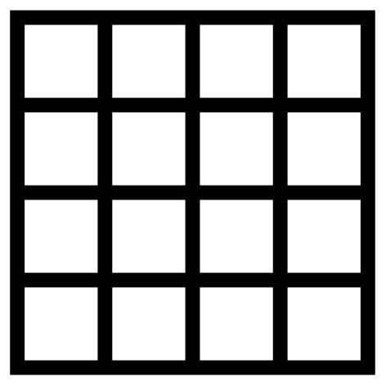
Definition: A grid-based dissection in which cells are arranged according to a repeating visual or mathematical pattern.
Example: A square grid has $4$ rows and $4$ columns, with alternating black and white cells.
Total cells:
$$N=4×4=16$$
Because the grid has an even number of cells in each direction, eight cells are black and eight are white.
If every cell has area $1$, then
$$A_{\text{black}}=8, A_{\text{white}}=8$$
This pattern is useful for studying equal-area regions, alternating arrangements, and symmetry.

8. Rearrangement-Based Grid Dissection
# Source: AI Source: Provided by: [Data Path: Persons Table -> ID Column: 1, Name_En Column: Motasem Essam] -> From: [ChatGPT] on [7/25/2026]
Uses grid-defined pieces that can be rearranged to form another figure.
Example: Four rectangular pieces cut from a \(12\times4\) rectangle and rearranged into a \(6\times8\) rectangle.
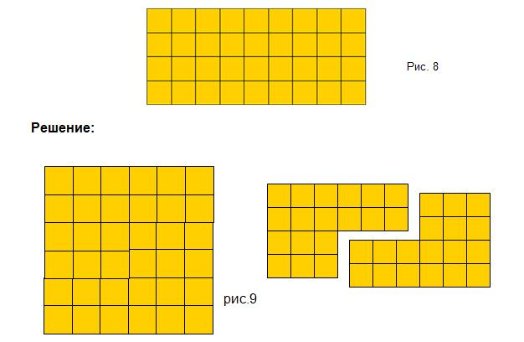
Detailed Explanation of Each Type
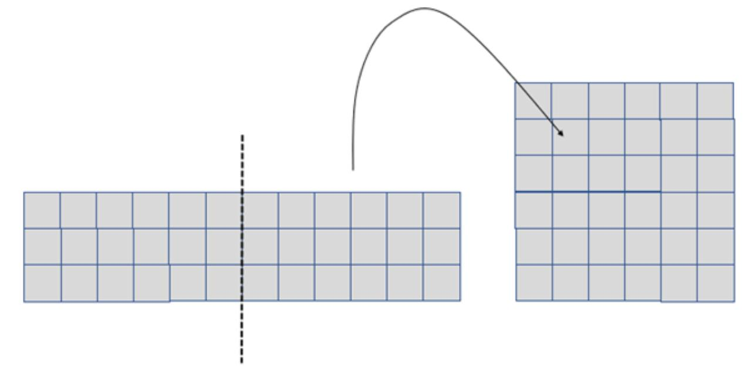
Definition: A grid-based dissection in which pieces are cut along grid lines and rearranged to form a different figure.
Example: A $12×4$ rectangle is divided into four $3×4$ rectangles. Rearrange the four pieces into a $6×8$ rectangle.
Original area:
$$A_{1}=12×4=48$$
New area:
$$A_{2}=6×8=48$$
Therefore,
$$\boxed{A_{1}=A_{2}=48}$$
The area is preserved because the same pieces are used without gaps or overlaps.

9. Equal-Area Grid Dissection
# Source: AI Source: Provided by: [Data Path: Persons Table -> ID Column: 1, Name_En Column: Motasem Essam] -> From: [ChatGPT] on [7/25/2026]
Divides a figure into regions with equal areas, using grid cells to make the partition clear.
Example: A \(6\times4\) rectangle divided into four equal-area regions, each of area \(6\).
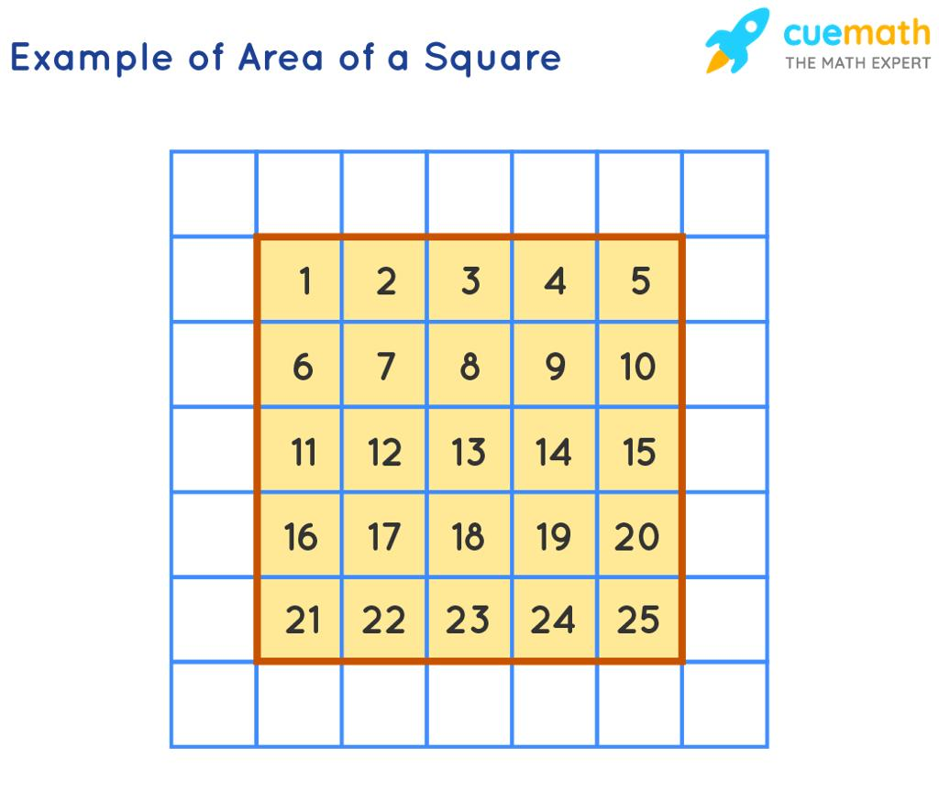
Detailed Explanation of Each Type
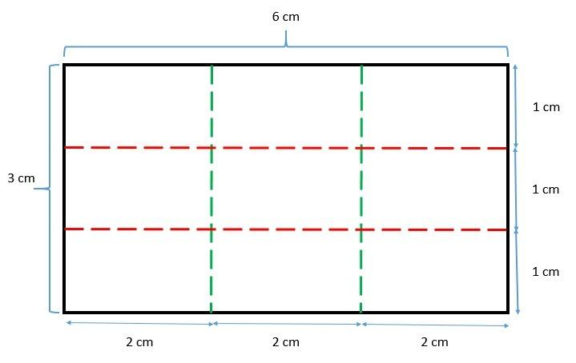
Definition: A grid-based dissection that creates regions with equal areas, even if the regions do not necessarily have the same shape.
Example: A $6×4$ rectangle is divided into four $3×2$ rectangles.
Original area:
$$A=6×4=24$$
Area of each of the four pieces:
$$A_{\text{piece}}=\frac{24}{4}=\boxed{6}$$
Here, the pieces are both equal in area and congruent. In other grid dissections, equal-area pieces may have different dimensions or shapes.

10. Grouped-Cell Grid Dissection
# Source: AI Source: Provided by: [Data Path: Persons Table -> ID Column: 1, Name_En Column: Motasem Essam] -> From: [ChatGPT] on [7/25/2026]

Combines adjacent grid cells into larger pieces, such as rectangles, squares, or L-shaped regions.
Example: Group twelve unit squares into three rectangles, each containing four unit squares.
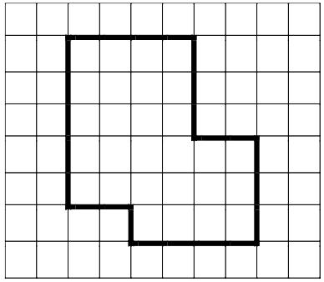
Detailed Explanation of Each Type
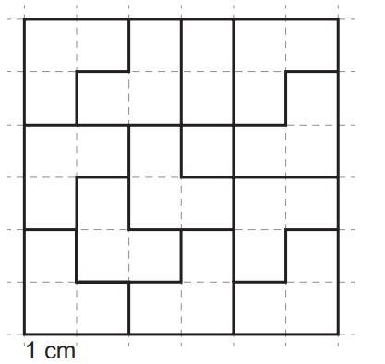
Definition: A method of combining adjacent grid cells into larger pieces after creating the initial grid.
Example: A $3×4$ grid contains $12$ unit squares. Group the cells into three $2×2$ squares.
Each group has area
$$A_{\text{group}}=2×2=4$$
The total area is
$$A=3×4=12$$
Important: The groups must cover the entire original figure without overlapping interiors or leaving gaps. If a group is intended to be rectangular, its cells must form a rectangle.

Key Formulas for Grid-Based Dissection
# Source: AI Source: Provided by: [Data Path: Persons Table -> ID Column: 1, Name_En Column: Motasem Essam] -> From: [ChatGPT] on [7/25/2026]
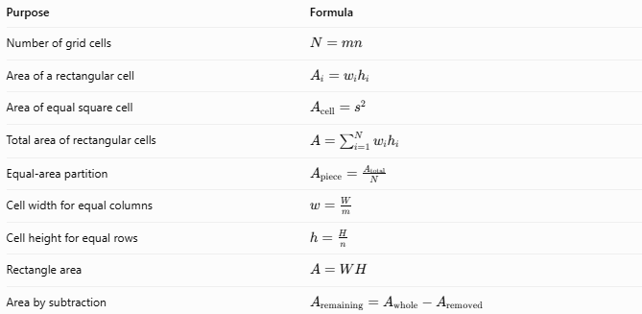
Purpose | Formula
Number of grid cells | $$N=mn$$
Area of a rectangular cell | $$A_{i}=w_{i}h_{i}$$
Area of equal square cell | $$A_{\text{cell}}=s^{2}$$
Total area of rectangular cells | $$A=\sum_{i=1}^{N}{w_{i}}h_{i}$$
Equal-area partition | $$A_{\text{piece}}=\frac{A_{\text{total}}}{N}$$
Cell width for equal columns | $$w=\frac{W}{m}$$
Cell height for equal rows | $$h=\frac{H}{n}$$
Rectangle area | $$A=WH$$
Area by subtraction | $$A_{\text{remaining}}=A_{\text{whole}}-A_{\text{removed}}$$
Here, $W$ and $H$ are the original rectangle's width and height, while $m$ and $n$ are the numbers of columns and rows.
For a grid with unequal cell dimensions, the total area is the sum of the individual cell areas. If the cells completely partition the original figure, this sum equals its area.

Comparison with Other Dissection Methods
# Source: AI Source: Provided by: [Data Path: Persons Table -> ID Column: 1, Name_En Column: Motasem Essam] -> From: [ChatGPT] on [7/25/2026]
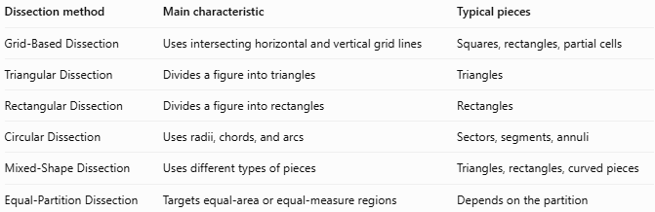
Dissection method | Main characteristic | Typical pieces
Grid-Based Dissection | Uses intersecting horizontal and vertical grid lines | Squares, rectangles, partial cells
Triangular Dissection | Divides a figure into triangles | Triangles
Rectangular Dissection | Divides a figure into rectangles | Rectangles
Circular Dissection | Uses radii, chords, and arcs | Sectors, segments, annuli
Mixed-Shape Dissection | Uses different types of pieces | Triangles, rectangles, curved pieces
Equal-Partition Dissection | Targets equal-area or equal-measure regions | Depends on the partition
Key distinction: Grid-based dissection describes how the cuts are organized, whereas rectangular, triangular, and circular dissection describe the shapes of the resulting pieces. These classifications can overlap: a grid-based dissection may also be a rectangular dissection or an equal-area dissection.

Classification Summary
# Source: AI Source: Provided by: [Data Path: Persons Table -> ID Column: 1, Name_En Column: Motasem Essam] -> From: [ChatGPT] on [7/25/2026]
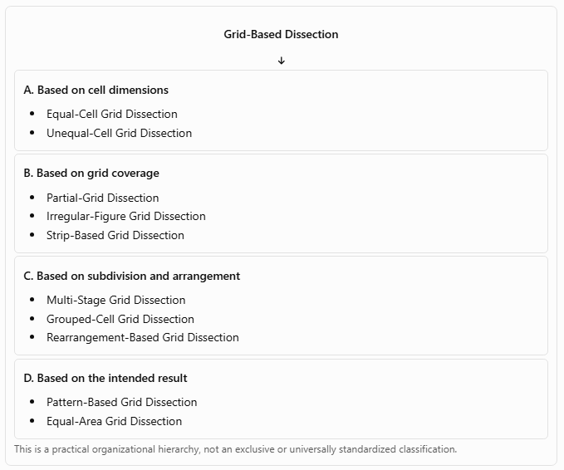
Grid-Based Dissection
A. Based on cell dimensions
- Equal-Cell Grid Dissection
- Unequal-Cell Grid Dissection
B. Based on grid coverage
- Partial-Grid Dissection
- Irregular-Figure Grid Dissection
- Strip-Based Grid Dissection
C. Based on subdivision and arrangement
- Multi-Stage Grid Dissection
- Grouped-Cell Grid Dissection
- Rearrangement-Based Grid Dissection
D. Based on the intended result
- Pattern-Based Grid Dissection
- Equal-Area Grid Dissection
This is a practical organizational hierarchy, not an exclusive or universally standardized classification.

Key Points
# Source: AI Source: Provided by: [Data Path: Persons Table -> ID Column: 1, Name_En Column: Motasem Essam] -> From: [ChatGPT] on [7/25/2026]
- Grid-based dissection uses horizontal and vertical lines to subdivide a figure.
- Grid cells may be equal or unequal in size.
- The method applies to regular shapes and many irregular rectilinear shapes.
- Cells can be grouped or subdivided again to produce different pieces.
- Rearranging pieces preserves area when all pieces are used without gaps or overlapping interiors.
- Equal-area pieces do not necessarily have equal shapes or dimensions.
- A grid can support area calculations, geometric proofs, visual patterns, and dissection puzzles.

Conclusion
# Source: AI Source: Provided by: [Data Path: Persons Table -> ID Column: 1, Name_En Column: Motasem Essam] -> From: [ChatGPT] on [7/25/2026]
Grid-Based Dissection is a flexible method of dividing geometric figures into smaller regions using a grid. Depending on the grid and the purpose of the dissection, the resulting pieces can be equal or unequal, regular or irregular, grouped or subdivided, and rearranged into new figures.
Its central mathematical principle is area preservation: when a figure is partitioned completely, the sum of the areas of its pieces equals the area of the original figure.

